The first thing you will need do is to get an account on GITLAB (<https://gitlab.lmms.lmco.com/>). It will be your enterprise NTID/Password so really it is just a matter of getting it “turned on”.

Once you are signed on I will add your access to all of the pertinent repos.

Next you will want to unpack the Eclipse Neon that I sent you and import the included team project set. Here are the steps to do so:

1. Run Eclipse Neon. A dialog will appear prompting you select a Workspace (it will probably be pre-populated something).  
   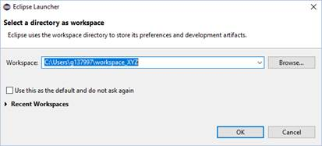  
     
   I locate my workspaces in the local home directory (i.e. **C:\Users\<NTID>**) and name the IER/JColisar one **workspace_IER** thus it becomes **C:\Users\g137997\workspace_IER**.  
   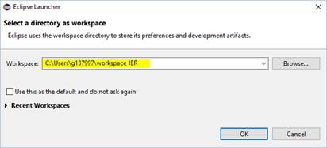
2. (Hopefully) Only on the first run of a new workspace the **Welcome** pane will appear. Dismiss it with the **X**.  
   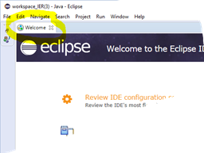
3. Select **Windows > Preferences** from the main window menu bar.  
   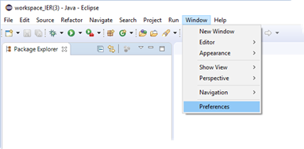
4. Go to the **Team > Git** page of the Preferences dialog. Click on the **Browse** button for the **Default repository folder:** field.  
   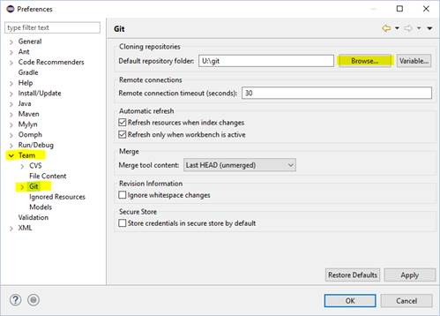
5. Navigate to and select your workspace directory and then click the **Apply** button at the bottom right of the dialog.  
   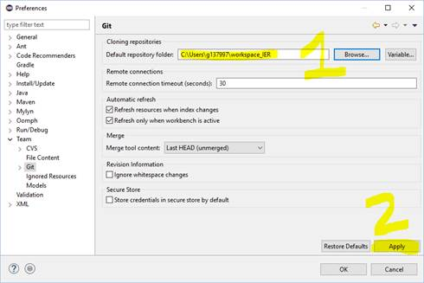
6. Select **File > Import…** from the main window menu bar.  
   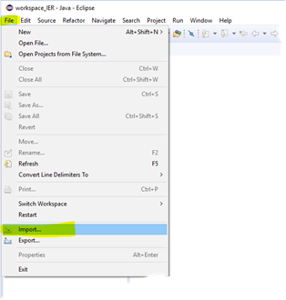
7. Go to the **Team > Team Project Set** item in the tree and click the **Next >** button  
   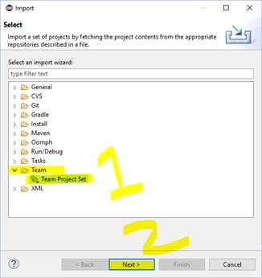
8. Navigate to and select the ***workspace_IER_HTTP190208.psf*** file that was sent to you. Then click the **Finish** button.  
   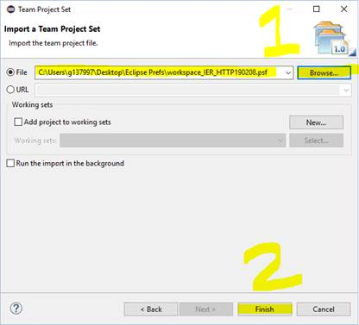
9. Next it will start to “churn and burn” while it makes local clones of the 3 repos.  
   ***NOTE:*** *I am not sure what form it will take but you will be prompted for your NT UserID/password on this step (My ID/Password were already cached so I was not prompted to enter them while creating this tutorial).*  
   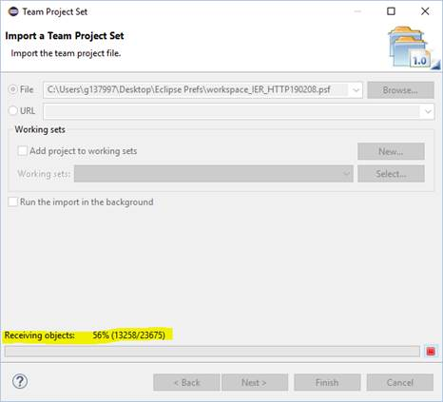
10. After a while (when all the “dust has settled”) your Eclipse should look something like the following:  
    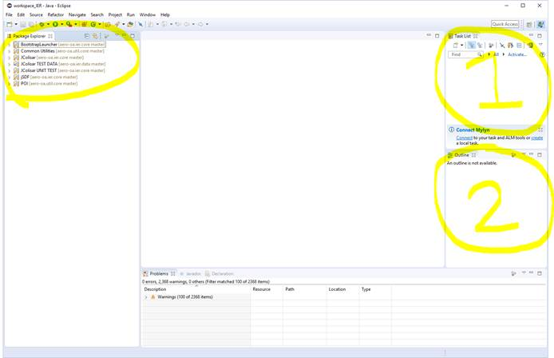
11. **SUGGESTION (Not Required):** We all have our preferences as to how we like out IDEs set up. In order to maximize the size of the main editor pane I usually do the following with mine:  
    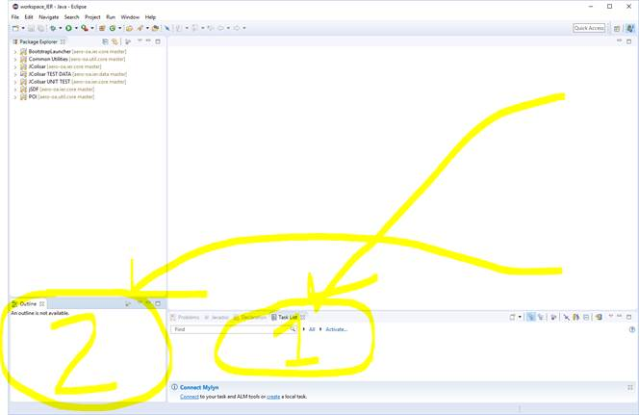
12. You will want to add the **GIT** perspective Quick Access icon.  
    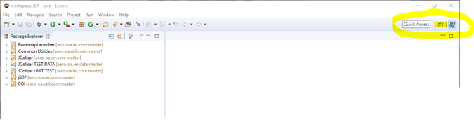  
    This is accomplished by first clicking on the cid:image014.png@01D4C9F8.78AC7EF0 and then selecting the **Git** item from the **Open Perspective** dialog.  
    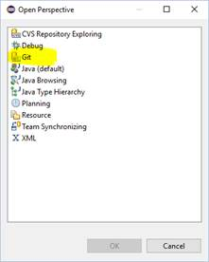  
    To end up with the **GIT** perspective Quick Access icon as follows:  
    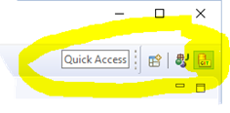  
    Upon adding the per the new perspective, it will also change to it such that the entire Eclipse will look like:  
    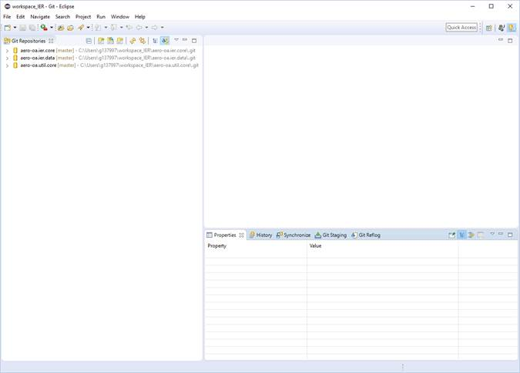  
      
    You can change back to the Java perspective by clicking on the cid:image018.png@01D4C9F8.78AC7EF0 icon in the Quick Access bar.

Upon initially cloning you will be in sync with the latest code. As time passes, however, you will want to “pull” any changes by doing the following:

1. From the GIT perspective select all 3 repos, right click somewhere over the selection and then select Pull from the popup menu.  
   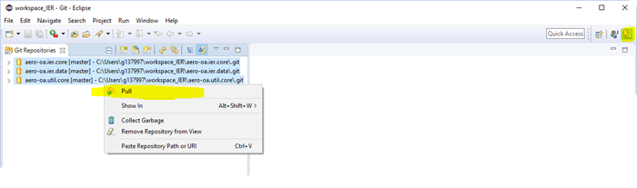  
   You will see a dialog something like:  
   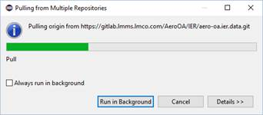  
   Once complete a dialog will appear looking something like:  
   